High Fidelity Electronic Piano

Ali AlRifai

Table of Contents

Abstract 4

High Fidelity Electronic Piano 5

Theoretical Considerations and Design Approach 6

Conceptual Overview 8

Simulations and Tests 12

Tasks and Organization 13

Experimental Procedure 14

Circuit Construction 14

Circuit Testing 16

Results 16

Discussion 20

Timeline and Milestones 20

Test Data vs. Simulations 21

Summary and Conclusion 23

References 24

Acknowledgments 25

**Table of Figures**

Figure 1: Wien-bridge oscillator [4]. 6

Figure 2: A Weighted Summer [5]. 6

Figure 3: Amplifier Module [6]. 7

Figure 4: The Circuit for an Astable Multivibrator [5]. 8

[Figure 5: Summing and Amplification Network.](https://d.docs.live.net/992c448482b854e1/1%20UH%20ECE/1%20Fall%202016/ECE%203355_%20Electronics/ECE%203155_Electronics_Lab_sec_22182/To%20be%20Submitted/Formal_Report_High%20Fidelity%20Electronic%20Piano.docx#_Toc468170223) 9

Figure 6: Typical Current Amplifier from page 28 of our textbook [5]. 10

Figure 7: Tow Op-Amps in Negative Feedback [10]. 11

Figure 8: Simulation of Amplification Stage with 1.175 and 1.48 [kHz]. 12

Figure 9: Simulation of Amplification Stage with 1.175, 1.48, 1.976 [kHz]. 12

Figure 10: Summer and Audio Amplifier Breadboard. 15

[Figure 11: Oscilloscope Snapshots of the Eight Wien-bridge Oscillators](https://d.docs.live.net/992c448482b854e1/1%20UH%20ECE/1%20Fall%202016/ECE%203355_%20Electronics/ECE%203155_Electronics_Lab_sec_22182/To%20be%20Submitted/Formal_Report_High%20Fidelity%20Electronic%20Piano.docx#_Toc468170229) 17

[Figure 12: Bode Plot for Summer Module data of Table 3 above.](https://d.docs.live.net/992c448482b854e1/1%20UH%20ECE/1%20Fall%202016/ECE%203355_%20Electronics/ECE%203155_Electronics_Lab_sec_22182/To%20be%20Submitted/Formal_Report_High%20Fidelity%20Electronic%20Piano.docx#_Toc468170230) 19

[Figure 13: Final Device Diagram.](https://d.docs.live.net/992c448482b854e1/1%20UH%20ECE/1%20Fall%202016/ECE%203355_%20Electronics/ECE%203155_Electronics_Lab_sec_22182/To%20be%20Submitted/Formal_Report_High%20Fidelity%20Electronic%20Piano.docx#_Toc468170231) 22

**List of Table**

Table 1: Eight Piano Keys and Their Frequencies [3]. 5

[Table 2: List of Circuit Parts](https://d.docs.live.net/992c448482b854e1/1%20UH%20ECE/1%20Fall%202016/ECE%203355_%20Electronics/ECE%203155_Electronics_Lab_sec_22182/To%20be%20Submitted/Formal_Report_High%20Fidelity%20Electronic%20Piano.docx#_Toc468130593) 14

Table 3: Theoretical (calculated) vs. Measured Frequencies and Percent Error. 16

Table 4: The Frequency Response of the Summer Module. 18

Table 5: Measure vs. Theoretical Gain of the Summer Module. 18

Table 6: Gain and Power for the Amplification Module. 19

**Abstract**

An electronic Piano utilizes eight Wien-bridge oscillator circuits, a summing module, an audio amplification module, and a speaker. Each one of the eight Wien-bridge oscillators produce one of the following notes and frequencies: D (1175 [Hz]), E (1319 [Hz]), F# (1480 [Hz]), G (1568 [Hz]), A (1760 [Hz]), B (1976 [Hz]), C# (2218 [Hz]), and D (2349 [Hz]). The summing network combines the keys outputs and mixes the different frequencies if the user pressed the Piano keys simultaneously. The output of this summer Module feeds the audio amplification stage which has a 10 [kΩ] trimpot voltage-divider for volume control. The circuit produces all the frequencies per the specifications with an average frequency error of 1.56 %. The maximum output power is 1.3 [W] delivered to an 8 [Ω] speaker with maximum output current of 410 [mA]. Our low, budget beginner pianist can use this device to enjoy an affordable Piano lessons training with an instrument that can be built from used parts found in old, retired electronic devices. Of course, our team is planning to release the devices schematics and specification to the public domain, free of charge.

Keywords: Piano, frequencies, output current, current amplifier, affordable electronic Piano.

**High Fidelity Electronic Piano**

About three centuries ago, an Italian harpsichord named Mark Bartolomeo Cristofori constructed the first Piano; Two hundred years before the development of the first operational electronic devices, Cristofori built a Piano using basic tools and materials [1]. However, the human ingenuity did not stop at Cristofori’s time and fundamental techniques but, instead, it ignited some new frontiers, in sound and audio, with the development of electronic three-terminal vacuum tubes and other modern semiconductor electronic devices [2]. However, an electronic Pianos, with today’s semiconductor devices, can be built with some low-cost electronic components and designed with the knowledge of electronics theory.

Utilizing eight Wien-bridge oscillator circuits, a summing network, an audio amplification module, and a speaker; Our team constructed an electronic Piano. Each of the eight Wien-bridge oscillators produces one for each of the notes and frequencies are shown in Table 1. The summing network combines the keys and mixes the different frequencies if one pressed the Piano keys simultaneously then feed the output to an audio amplification module that has a 10 [kΩ] trimpot voltage-divider for volume control.

Table 1: Eight Piano Keys and Their Frequencies [3].



Our low-budget beginner pianist can use one or two of these devices to enjoy an affordable training with a device that, can be built from used part found in many old electronic devices. Of course, our team is planning to release the devices schematics and specification to the public domain, free of charge.

# Theoretical Considerations and Design Approach

Our team decided to go with module design approach which allows us to divide work equally between team members. Our project had three main modules:

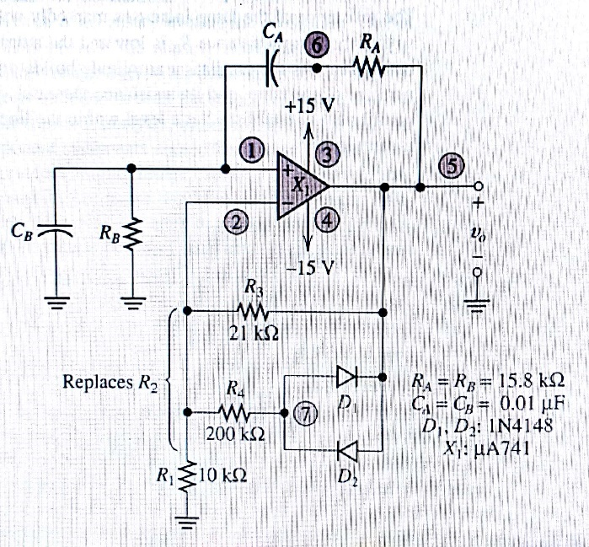

Figure 1: Wien-bridge oscillator [4].

1. A Wien-bridge oscillator Module:

Francisco and Andy built the Wien-bridge oscillators. Dr. Wolfe declined the first circuit schematic in our proposal because it utilizes an old two lamps, design; therefore, we decided to use the two diodes for stabilization in the design from Dr. Hampley’s textbook, see Figure 1. The circuit works well with a 741 op-amp and +15 [V] and -15[V] DC power supply.

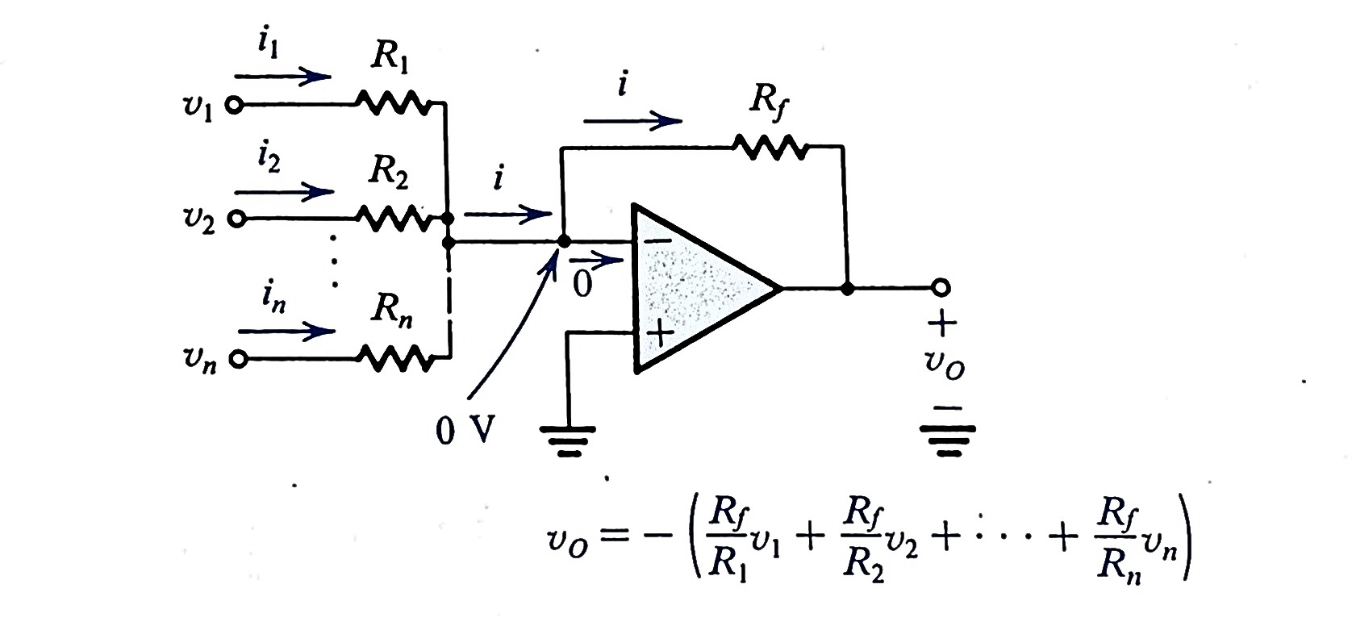

Figure 2: A Weighted Summer [5].

1. A Unity Summer Module:

One of the critical applications of operational amplifiers is the weighted summer, see Figure 2. The weighted summer has a resistance in the negative-feedback path and number of input signals each applied to resistors , in our case eight resistors were used for the eight inputs of the Piano. The Unity Summing Module is used to combine the different audio frequencies of each of the eight notes shown in Table 1 above.

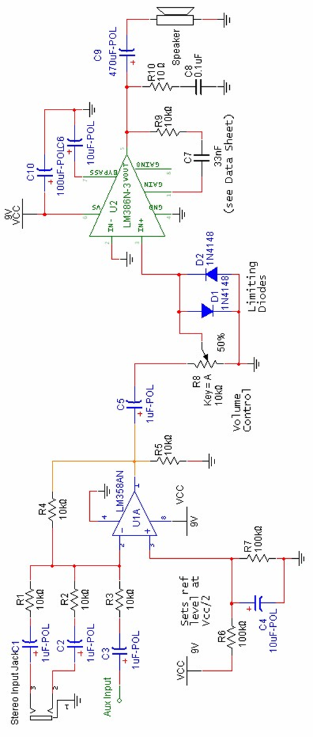

Figure 3: Amplifier Module [6].

1. An Audio Amplifier Module:

Audio amplifiers are current amplifiers with current outputs around 250 [mA] or more to produce audible sound on a typical 8 [Ω] speaker. Texas Instruments designed the LM386 chip as an audio driver with about 25 [A/A] current amplification. The schematic for an LM386-based amplifier is shown in Figure 3 above. We constructed this amplifier using our plastic solderless breadboard and bench power supply. Then we changed the power supply with a 9 [V] battery for mobility.

# Conceptual Overview

**Wien-bridge Oscillator:**

In chapter 18 – page 1412 of our textbook [5], we learned that we could build an oscillator connecting resistors and capacitors together with an inverting amplifier to produce an oscillating signal. The circuit that we studied in the classroom with Dr. David Shattuck was the Astable Multivibrator where a capacitor is charging-discharging through a resistance toward a final voltage.

, where is the voltage at t = 0+ and τ = CR which is the time constant, see Figure 4 below.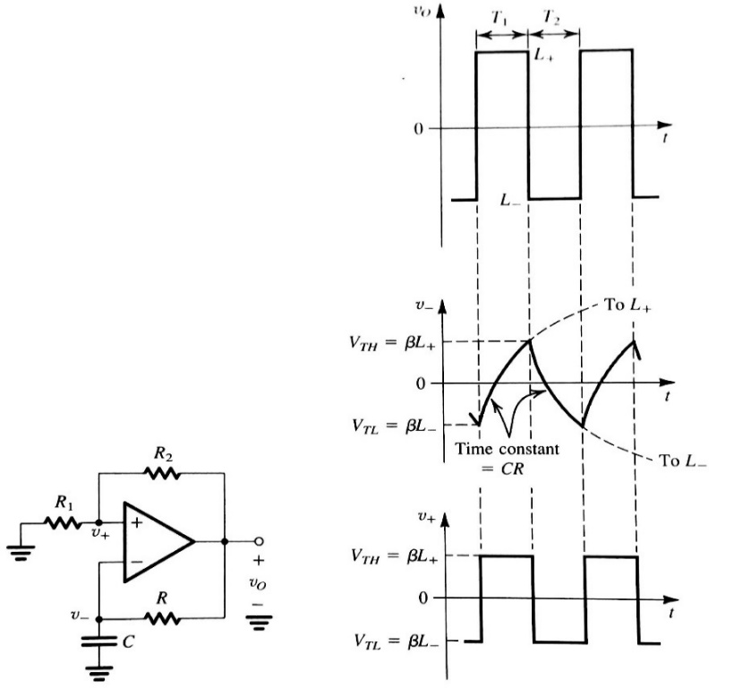

Figure 4: The Circuit for an Astable Multivibrator [5].

The Astable produce a square wave with peaks between the In a similar manner, the Wien bridge oscillator works to produce a sinusoidal signal with two capacitors, as seen in Figure 1 above. However, instead of one capacitor as in the Astable Multivibrator, the output of the Operational amplifier is feedback with two capacitors to both the inverting and non-inverting input of the op-amp through a voltage divider and diodes network to create the sinusoidal output [7]. The voltage gain of the amplifier circuit must equal or greater than 3; therefore, the input is 1/3 of the output. This value, (Av ≥ 3) is set by the negative feedback resistor network, R1, R3, and R4.

The Wien Bridge Oscillator frequency is:

One might notice that there is no input to the Wien-bridge oscillator but the oscillation starts by noise available in the surroundings such as radio noise, cosmic, and power lines electromagnetic fields, and so forth. The smallest amount of noise starts the oscillator and causing building up the charge in the capacitors and continue to work if the breadboard continues power supply to the op-amps.

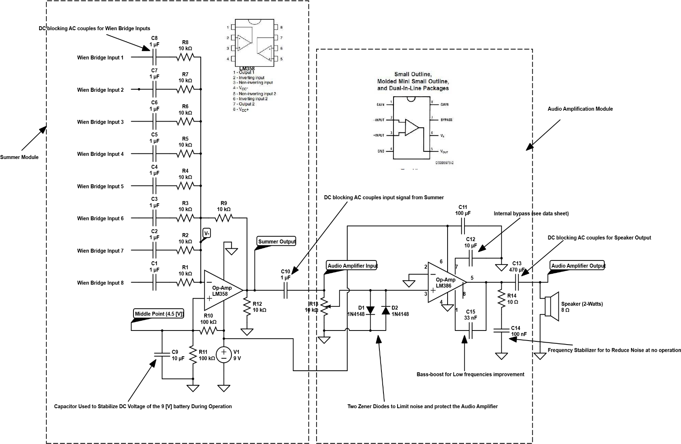

Figure 5: Summing and Amplification Network.

**The Unity Summing Module:**

Our summer uses a 9 [V] Lithium battery and coupling capacitors. Therefore, we must mention three important points in regards to the utilization of a battery as power supplies:

1. Our textbook shows the Weighted Summer network, see Figure 2, with the non-inverting input, usually grounded; however, since we are using a 9 [V] battery, we had to find the midpoint of the voltage using a voltage divider to determine half the supply voltage, 4.5 [V]. In a dual bipolar power supply, the midway voltage is the ground. However, our ground is a 4.5 [V] which allow a maximum swing of the AC component of the input signal (from 0 to 9 [V] in this case). The 4.5 [V] ground, or common point, is accomplished by using two 100 [kΩ] resistors in a voltage divider. A 100 [kΩ] is used to minimize the current drawn from the battery and prolong battery life.
2. The second consideration for using a 9 [V] Lithium battery is the tendency of the output voltage to fluctuate during operation just like any other Lithium battery (non-ideal voltage source). Therefore, we use a bypass capacitor (10 [μF]) to prevent the voltage from fluctuating in parallel with the 100 [kΩ] resistors of the voltage divider, see Figure 5. The bypass capacitors are used to reduce the ripple effect of the battery during AC input.
3. 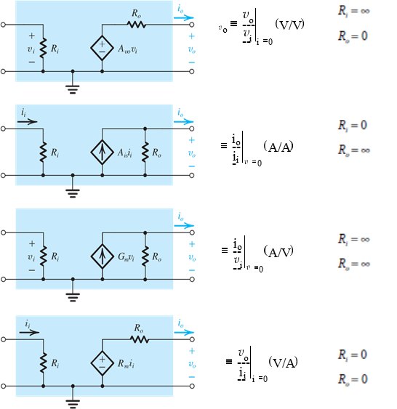Finally, for a capacitively coupled Wien-bridge oscillator inputs, the data sheet of the LM358AN recommends a resistive DC path to ground from the output terminal; therefore, we connected a 10 [kΩ] resistor to the output of our summer [8]. As for the choice of the value of the resistor that provides the dc path, we found that for our unity amplifier, the 10 [kΩ] maintains the same AC current throw the input non-inverting terminal and the non-inverting path [9]. Also, we notice in our online research that in most summer network circuits the dc paths between the output of the op-amp to the ground always have a similar resistor to that of the input signals.

Figure 5: Typical Current Amplifier from page 28 of our textbook [5].

**The Amplifier Stage:**

Our amplifier stage is using a current amplifier with and , see figure 6 above. However, the LM386 chip datasheet requires to connect the following components [6]:

1. A 1 [μF] capacitor: DC blocking, AC couples the input signal.
2. A 10 [k] trimpot: voltage-divider for volume control.
3. A 10 [μF] capacitor: Internal AC bypass.
4. A 10 [kΩ] resistor and 33nF capacitor between pins 1-5: bass-boost feedback

circuit (see data sheet), helps compensate for the poor low-frequency response of our speaker.

1. A 470 [μF] DC blocking capacitors.
2. A 10 Ω resistor and 100 [nF] capacitor: a “snubber” circuit for high-frequency

stabilization prevents potential oscillation due to inductive loading.



Figure 6: Tow Op-Amps in Negative Feedback [10].

**Second Amplification Module (possible future improvement):**

Zanne and Huy built the first amplification stage. Unfortunately, we could not have a final working circuit by the project demo due date. The circuit testing shows choppy and noisy output and overheating junctions. The design of their circuit was a basic current amplifier using a negative feedback for two LM386 low-power amplifiers, see figure 7 above. Our team decides to include this module as a possible future improvement to the present working amplification stage that can be added in cascaded amplifier network to increase output power; the cascaded network mentioned on page 25 of our textbook [5]:

Of course, this multistage amplification can be done after employing some improvements to the present circuit design. I mentioned these enhancements in more details in the **Test data vs. Simulations** section located at page 20 of this report.

## Simulations and Tests

We did our summer/amplifier simulation using the circuitlab.com website. The website lacks many important features such as oscilloscope frequency measurement. The website provides oscillator output only but without frequency measurement functions. However, we are planning to use PSpice in any future project because of its extensive useful features. We took an oscilloscope measurement across the speaker, see label Audio Amplifier Output in Figure 5.

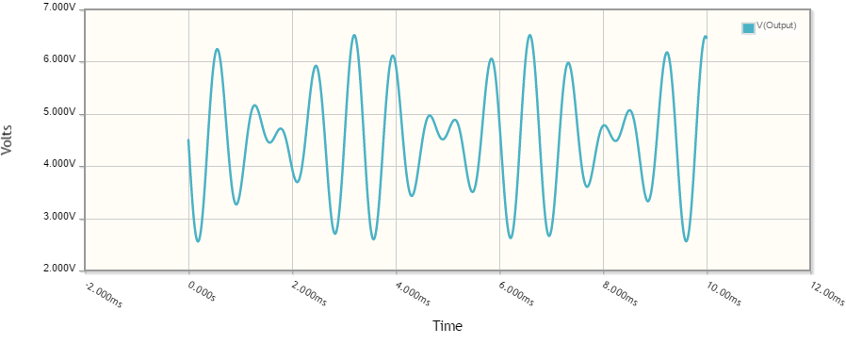

Figure 7: Simulation of Amplification Stage with 1.175 and 1.48 [kHz].

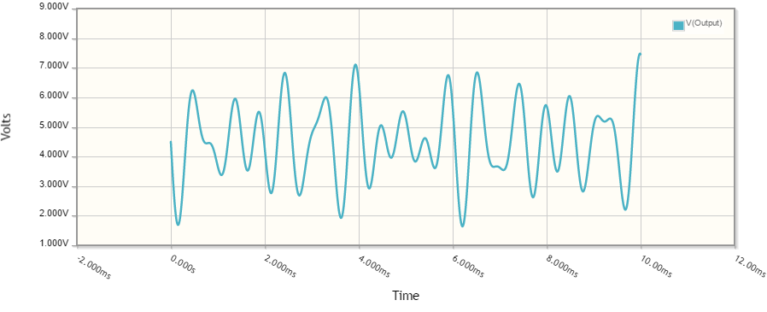

Figure 8: Simulation of Amplification Stage with 1.175, 1.48, 1.976 [kHz].

## Tasks and Organization

Our project started on September 05, 2016 and was delivered on time to Dr. Wolfe on November 19, 2016, at 2:30 PM. Our Team completed the Electronic Piano’ milestone, timeline, and task as follows:

1. The project proposal was done and delivered to Dr. Wolfe on time on September 29.
2. The audio Weighted Summer was originally scheduled to be done by Ali and Andy; however, Ali completed the summer. This task was shifted about four days and completed on October 10. The reason for the delay was shipment delay of the LM358 IC from mouser.com.
3. The testing of the Audio Weighted Summer was scheduled to be done by the team this task was done on schedule.
4. Zanne, Ali, and Huy were mandated to do the amplification module. However, Zanne and Huy excluded Ali from work with them and decided that they can do it by themselves. Unfortunately, Zanne and Huy did not complete the task, and the milestone drifted to November 10. On the other hand, Ali was working on a backup amplification module that he found online. The amplification circuit that Ali built was chosen by the team leader, Francisco, to be the main amplifier module used in our demo for Dr. Wolfe. Ali completed testing and data collection of the amplifier on November 15th.
5. Wien-bridge oscillator: Francisco and Andy completed this milestone on schedule on October 27. On November 06, Francisco, Ali, and Andy completed the testing and took measurements for results sections of the formal report.



Table 2: List of Circuit Parts

# Experimental Procedure

## Circuit Construction

The circuit construction went smoothly for the summer and amplifier stage. Table 2 shows all the parts used in the building of the circuit. Except for some occasional disconnections and loss wires, we constructed the modules quickly and with relative ease. One problem that we faced when we connected the modules was when we did not connect the ground points of the different modules which cause no output signals. Another issue, battery exhausted quickly, aroused when we decided to use lower resistors on the voltage divider resistors of our summer, R10, and R11, see Figure 5. Finally, we decided to remove the 470 μF capacitor C13, Figure 5, because we notice that would improve the sound quality, but it causes the LM386 chip to overheat. The LM386 overheated because of the increased DC path current which was initially blocked by the C13 capacitor. We decided to keep the capacitor to prolong the life of the LM386 chip.

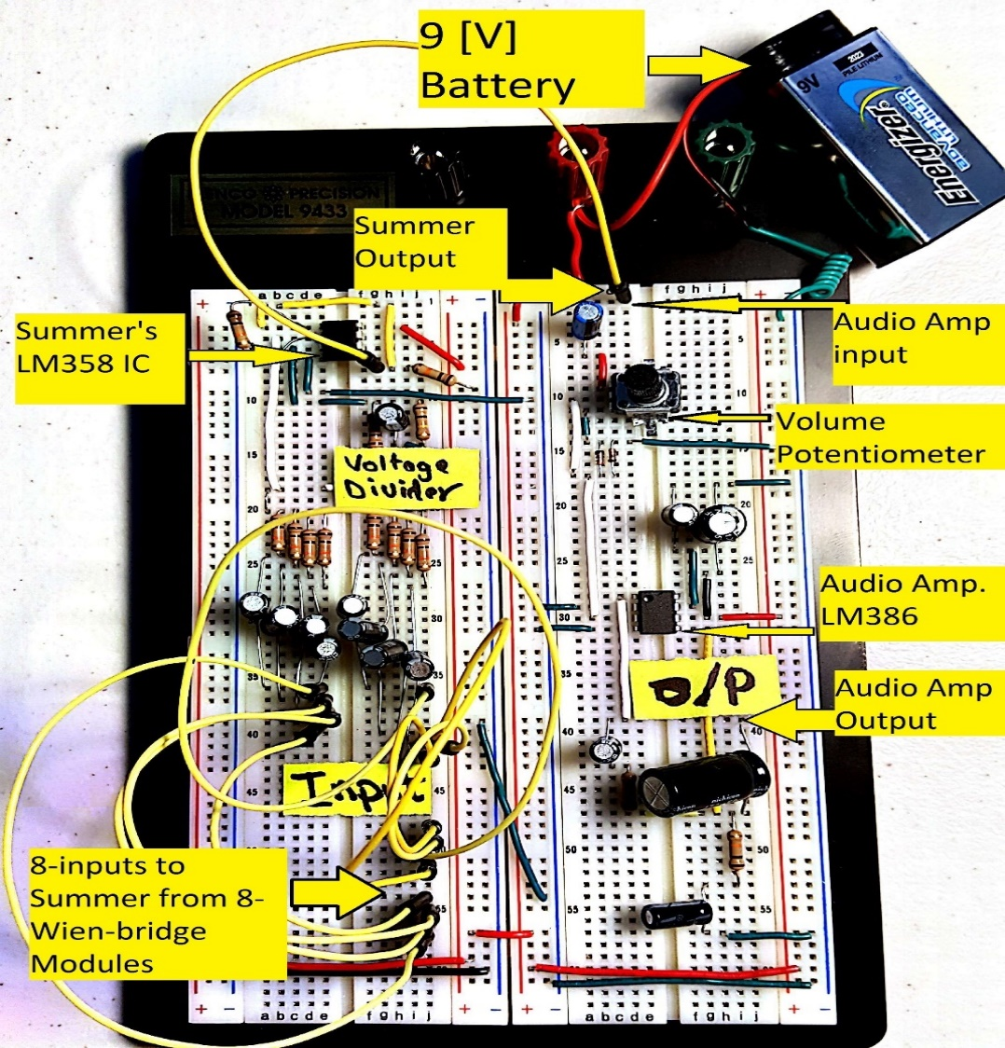

Figure 9: Summer and Audio Amplifier Breadboard.

Our design team included eight notes in the D-major scale. The frequencies that were selected and written on the proposal were not satisfactory because the waves were saturated (clipped), and we noted that the 741 op amps were being oversaturated [3]. We decided then that we should adhere to the example given in Allan R. Hambley’s textbook. Which was producing frequencies that were above 1000 [Hz]? We then shifted our values to be above the 1000 [Hz] as well but making sure that they still played the desired notes that we wanted for the electronic Piano. The circuit produced sinusoidal waves, further on, our calculations reveal that the frequency depended on the values of the resistors and capacitors being used on the non-inverting input as explained on page 8, the **Conceptual Overview** section, of this report.

## Circuit Testing

Please refer to Figure 5-page 9 of this report above, the circuit diagram of the summer and amplifier modules, and to Figure 10-page 15 above, the actual circuit breadboard. The test parameter was a sinusoidal 2 [V] peak-peak at frequencies ranges from 10 to 1500 [Hz]. The input was the summer module, and the output was the speaker. The output was taken at point 5, see Figure 1, for the Wien-bridge oscillators. There were eight outputs frequencies measured by an oscilloscope, see results below in Figure 11.

We tested the amplification stage by varying the potentiometer, and the amplifier’s input voltage, as a result, to cause the input voltage to range from 2 to 4.4 [V]. We choose this voltage because a minimum of 2[V] was necessary for an audible.

# Results

The Wien Bridge Amplifier Module

After building the circuits for each of the outputs, we took the output measurement of the individual circuits for the different notes, as seen in Table 3 below.

Table 2: Theoretical (calculated) vs. Measured Frequencies and Percent Error.



We have included some snapshots of the oscilloscope reading for the eight Wien-bridges outputs built for our Piano, see Figure 11 below.

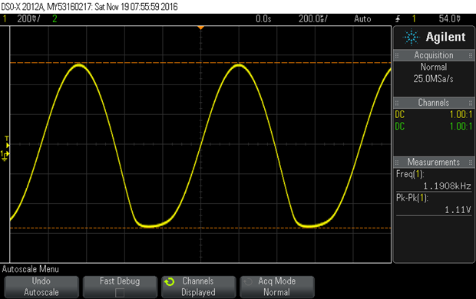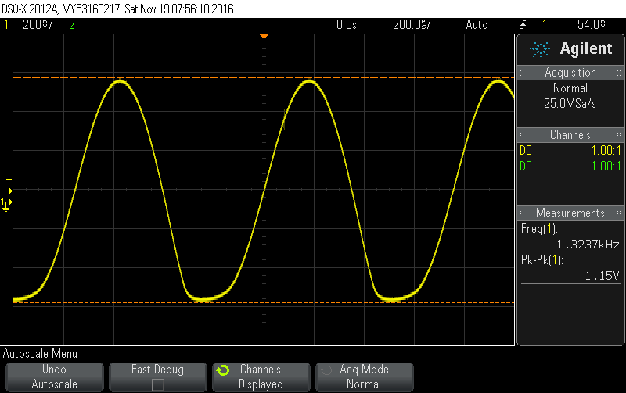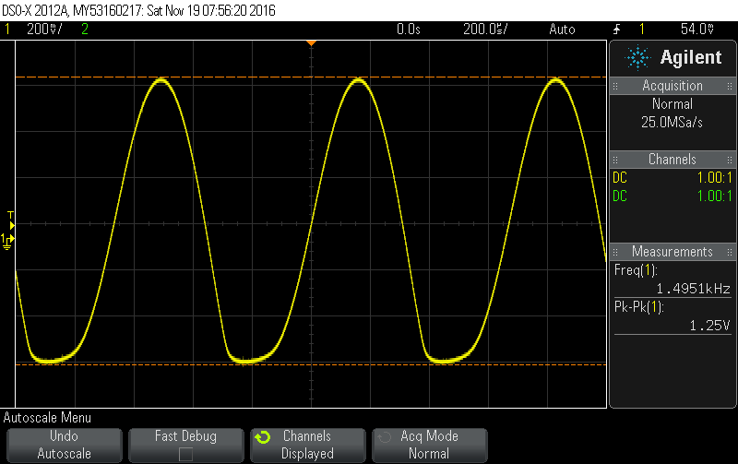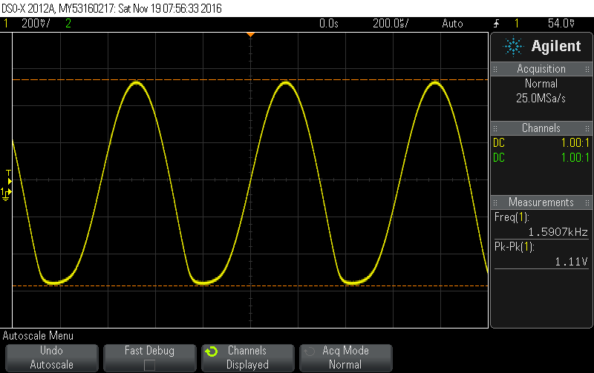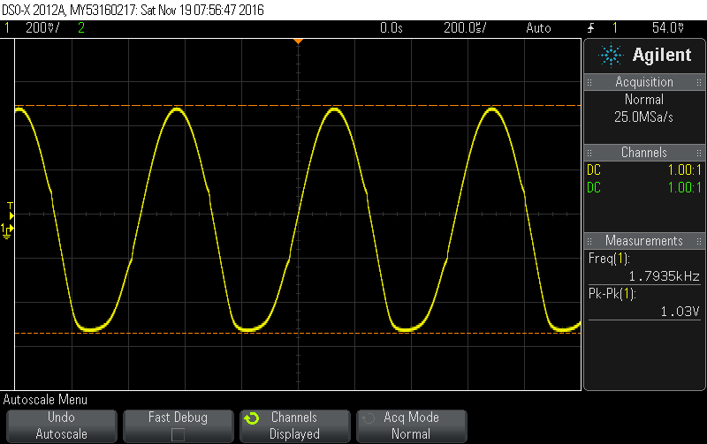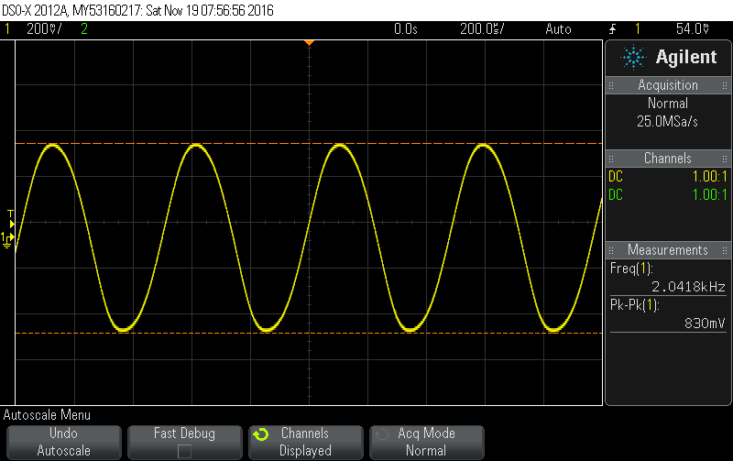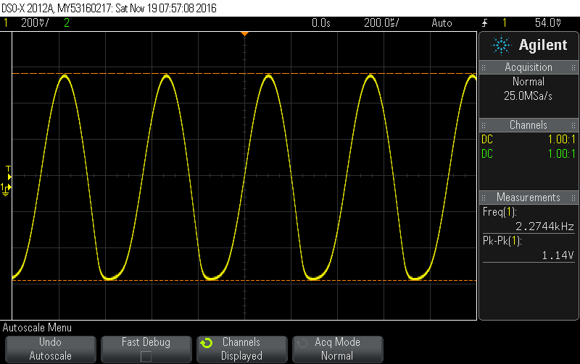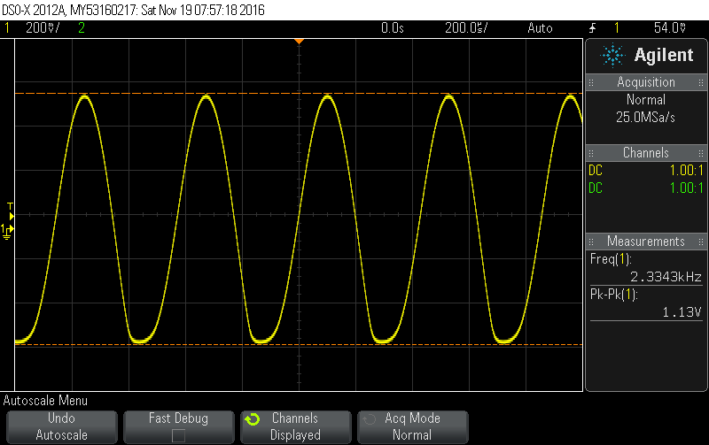

Figure 10: Oscilloscope Snapshots of the Eight Wien-bridge Oscillators

The Summer Module

We test the summer module by varying the frequency from 10 to 1500 [Hz], see Table 4, to find out the cutoff frequency at -3 [dB] from the baseband as seen in the Bode Plot, Figure 12.

Table 3: The Frequency Response of the Summer Module.



The gain did not reach 0 [dB] which corresponds to a unity gain because of the circuit loses and the possible errors that appear from resistors tolerance and measuring devices errors. It is good to mention here that our resistors tolerance is ± 5%.

In Table 5 below, choosing the operation frequency of the summer module (between 1000 to 1500), we can see that the average error in the gain is 1.93%, keeping in mind that the theoretical gain should be -1 [V/V] for our weighted summer.

Table 4: Measure vs. Theoretical Gain of the Summer Module.

We test the Amplifier module by inserting an ammeter in series to test the AC current flowing through the 8 [Ω] speaker as shown in Table 6 below:

Table 5: Gain and Power for the Amplification Module.



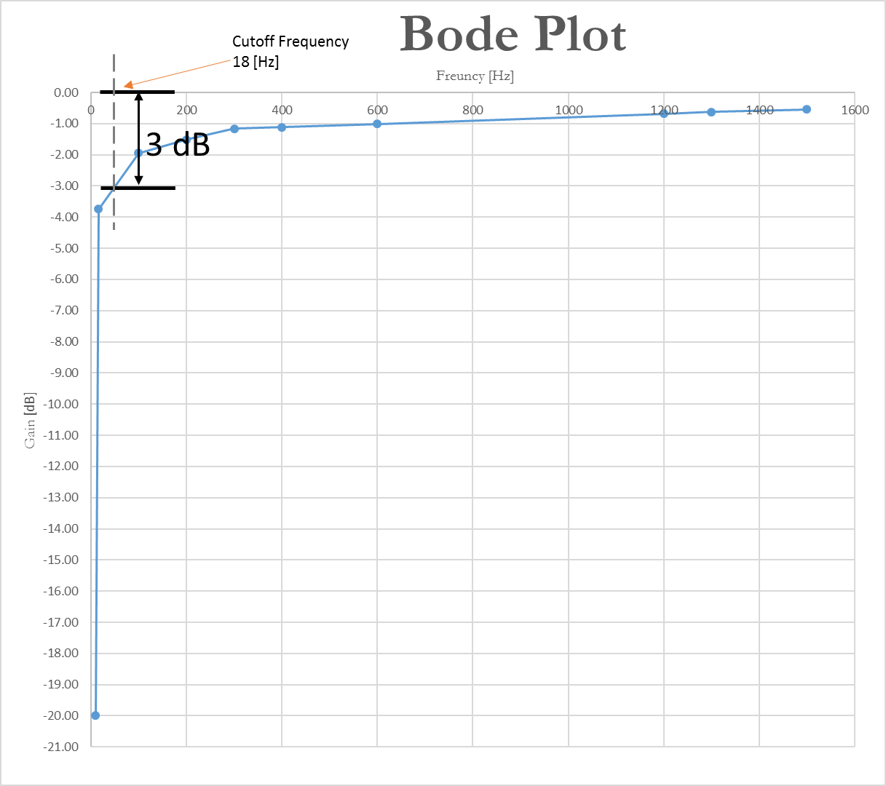

Figure 12: Bode Plot for Summer Module data of Table 3 above.

We notice that, in Table 6 above, as we increase the input current, the power increase at the output. The gain for the amplification stage is 20 [A/A] which corresponds to 26 [dB]. However, at step No. 4 in Table 6 above, we decided that maximum voltage is 4.5 [V] and not 5 [V]. A 5 [V] input will cause the output to saturate and exceeds the voltage supplied to the LM386 – audio amplification stage op-amp voltage is 4.5 [V] from the voltage divider of the summer stage, see Figure 13 on page 22. The input voltage was changed using the potentiometer on a breadboard.

The graph intersects the 18 [Hz] frequency at -3 [dB]; however, the calculation shows that the cutoff frequency is 15.92 [Hz], see below Bode Plot, Figure 12.

Theoretical calculation of cutoff frequency:

, R = 10 [kΩ] and C = 1 [μF], where R and C are any of the summer input or output resistors or capacitors.

Cutoff frequency measurement error:

# Discussion

## Timeline and Milestones

We have met our timeline and schedule for the project for most of the tasks; however, we had a problem with the amplification stage done by Zanne and Huy. Zanne and Huy did not take their circuit schematic from any reliable source of a working, tested circuits. Instead, they took it from our class notes which were designed to explain the general theory of op-amps, especially the negative-feedback idea, not as a working circuit. The example used by Zanne and Huy assumes that the designer did all the necessary biasing and capacitor coupling required for the circuit to work. Of course, the circuit would work if more modification was made to match the current and noise limitation of the chip used and to block the dc component of the output from leaking to the load. However, I decided to include the module as a possible future improvement to the audio amplification stage. If we can get Zanne and Huy module to work properly, we can add it in cascade with the working amplifier module to get higher power to produce more wattage for a bigger speaker. The total improved amplification will be:

Our project met the specification, frequency, and clarity, outlined in the introduction. However, our team did not meet the cost promise of the Piano. I think we underestimated how inexpensive electronics becomes in the last few decades. Our cost was over 60 dollars just in materials; however, amazon.com sells better Pianos can for less than 60 U.S. dollars. This Piano will be a great project for a person who wants to learn about basic electronics but not a real money-making project. However, the project could be affordable if we built it by parts from retired or old electronic devices.

## Test Data vs. Simulations

Per the theory of op-amps with negative feedback, Zanne and Huy's op-amp did not work properly (choppy sound at low frequencies and no output at high frequencies). However, the circuit, see Figure 7, has great potential to work if the following modification, per the LM386 chip data sheet provided by Texas Instruments [8], were to be made:

1. A DC blocking capacitors were added at the input and output to AC couple the input signal and output signals.
2. A 10 [kΩ] resistor and 33 [nF] capacitor between pins 1-5: bass-boost feedback

circuit to help compensate for the poor low-frequency response of our speaker

1. A 10 [Ω] resistor and 100 [nF] capacitor was connected in parallel with the output to prevent oscillation.

The Summer and Amplifier Modules:

On the other hand, the final working summing and amplification module did not produce outputs like the simulation data of the circuitslab.com output. Instead, the oscilloscope read noisy output. We tried to adjust the trigger of the signal, both manually and automatically, and take snapshots breaks, but it still noises. We believe it could be our probe and the chip LM386, and LM356, quality when dealing with multiple input frequencies. A problem that might arise when using cheap IC to mix high frequencies. A possible solution is the use of higher end chips audio chips such as the OPA2134PA manufactured by Texas Instruments. However, the AC current on the output and power calculation seems to follow the theoretical gain of the op-amp, using the configuration suggested by the chips data sheets.

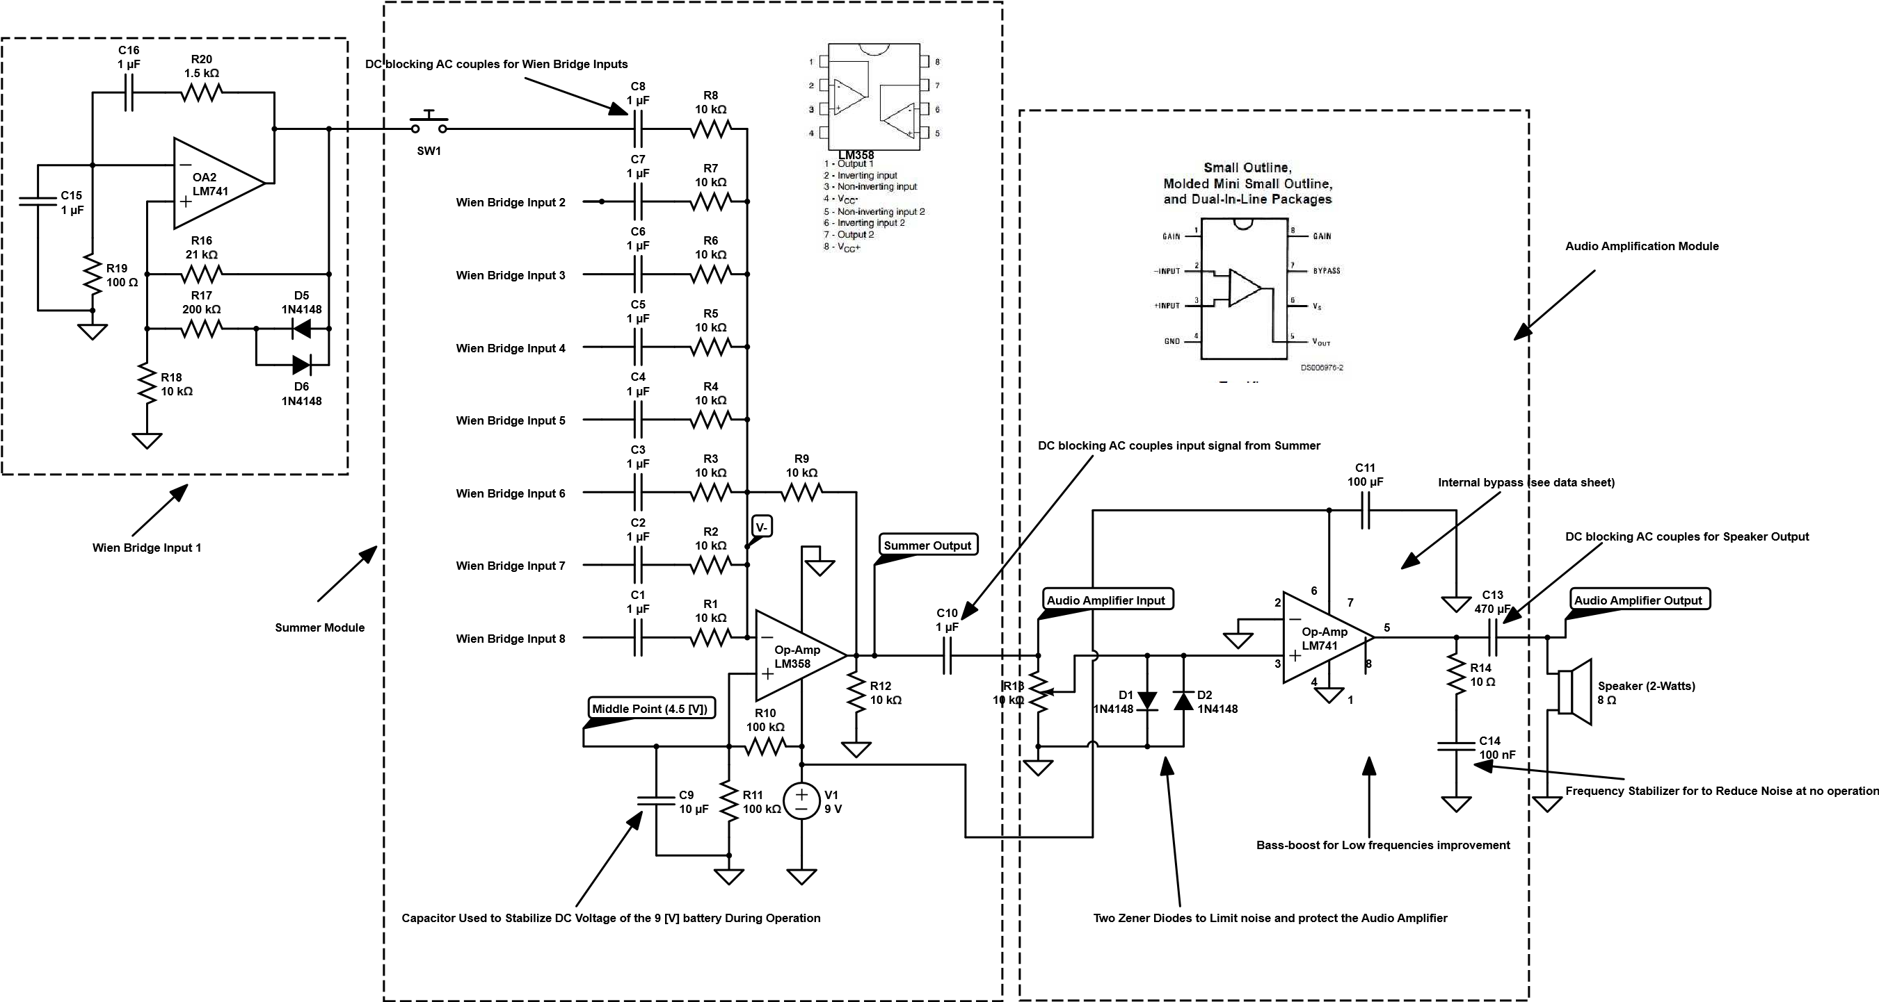

Figure 11: Final Device Diagram.

# Summary and Conclusion

One great benefit of this project was to value the hands-on experience acquired. The Design and implementation phases are to parts that modify each other. As we proceed with the project, we find new ways and methods to implement what we learn in the classroom. We, Team Falcon, built the three different modules and repeating the Wien-bridge module eight times to construct the various frequencies required by the specifications, see final device diagram Figure 12 above.

The average error in frequency produced by the Wien-bridge was around 1.56%, see Table 3 above. Our team concluded that Wien-bridge oscillators are very efficient and accurate in producing desired frequencies. However, the Wien-bridge works a lot more efficiently producing frequencies over 1000 [Hz]; therefore, we change the original specifications of the frequencies to start from 1 [kHz]. For the summing module, the cutoff frequency measured from Bode plot was around 18 [Hz] while the calculated frequency was 15.92 [Hz] with a measurement error of 13%. And the amplification stage can produce up to 1.3 [W] per our calculation. The output power of the amplification stage is typical for a low-power audio amplifier chip such as the LM386. The summer output gain was less than -1, for our , with an average error in a summer’s gain was 1.93%; therefore, the summer module is a very effective in summing the signals in the passband and specifically in our desired frequencies above 1000 [Hz] and less than 2200 [Hz]. Finally, our device passband is at least between 18 [Hz] and at least 2500 [Hz] which very suitable for the frequencies used for this Piano. However, the chip data of both LM386 and LM386 show that it can handle higher frequencies.

# References

[1] Siepmann, J. (1998). The Piano. Hal Leonard; Edition Unstated edition (November 1998).

[2] Adams, M. (2011). Lee de Forest: King of Radio, Television, and Film. Copernicus; 2012 edition (October 17, 2011). Retrieved November 05, 2016.

[3] Gomez, F., & Nguyen, A. (2016). Wien Bridge Oscillator.

[4] Hambley, A. R. (1994). Electronics: A Top-Down Approach to Computer-Aided Circuit Design. Macmillan Coll Div, page 552-553.

[5] Sedra, A. S., & Smith, K. C. (2015). Sedra/Smith Microelectronic Circuits. New York: Oxford University Press, page 71.

[6] York, B. (2007, November 04). Audio Amplifier Circuit. Retrieved October 09, 2016, from http://www.ece.ucsb.edu/Faculty/rodwell/Classes/ece2c/labs/Lab%201a%20-

[7] Garage, E. (2016, November 20). http://www.electronics-tutorials.ws/. Retrieved from Electronics Tutorials: http://www.electronics-tutorials.ws/oscillator/wien_bridge.html

[8] Insturments, T. (2006). Symlink: Literature Number: SNAS545A. Retrieved from Texas Instruments: http://www.ti.com/lit/ds/symlink/lm386.pdf

[9] Questions About Capacitors. (2016, November 05). Retrieved from Electronics Stack Exchange: http://electronics.stackexchange.com/questions/5830/are-decoupling-capacitors-needed-with-battery-power

[10] Soliz, Z., & Huh, H. (2016). Amplifier Module.

# Acknowledgments

This implementation of this project would not be possible without the help and support of Dr. Jack Wolfe and Dr. David Shattuck. Dr. Wolfe and Dr. Shattuck gave our team their indivisible attention and helped with explaining core and advanced principles of the circuits and electronics theory. Although many of these concepts have been taught to us before on numerous occasions and ECE classes, both Dr. Wolfe and Shattuck reiterated them repeatedly with patience and, always, a smile.

On a professional level, Dr. Wolfe taught us great lessons on how to work with each other as team members and how to give credit to others when it is due by proper citation. Also, Dr. Wolfe handled our drama and complaints about each other performance, or lack of it, with patience and respect. Our team will take these professional workplace lessons to the engineering work field, and his wisdom will be remembered forever.

Finally, our team is truly indebted to Mr. Francisco Gomez, our team leader, for the time and work that he invested in this project. As our liaison with Dr. Wolfe and Dr. David, Francisco conducted our questions and concerns with accuracy and speed spending hours researching and writing emails to respond to our inquiries and handling our meetings.